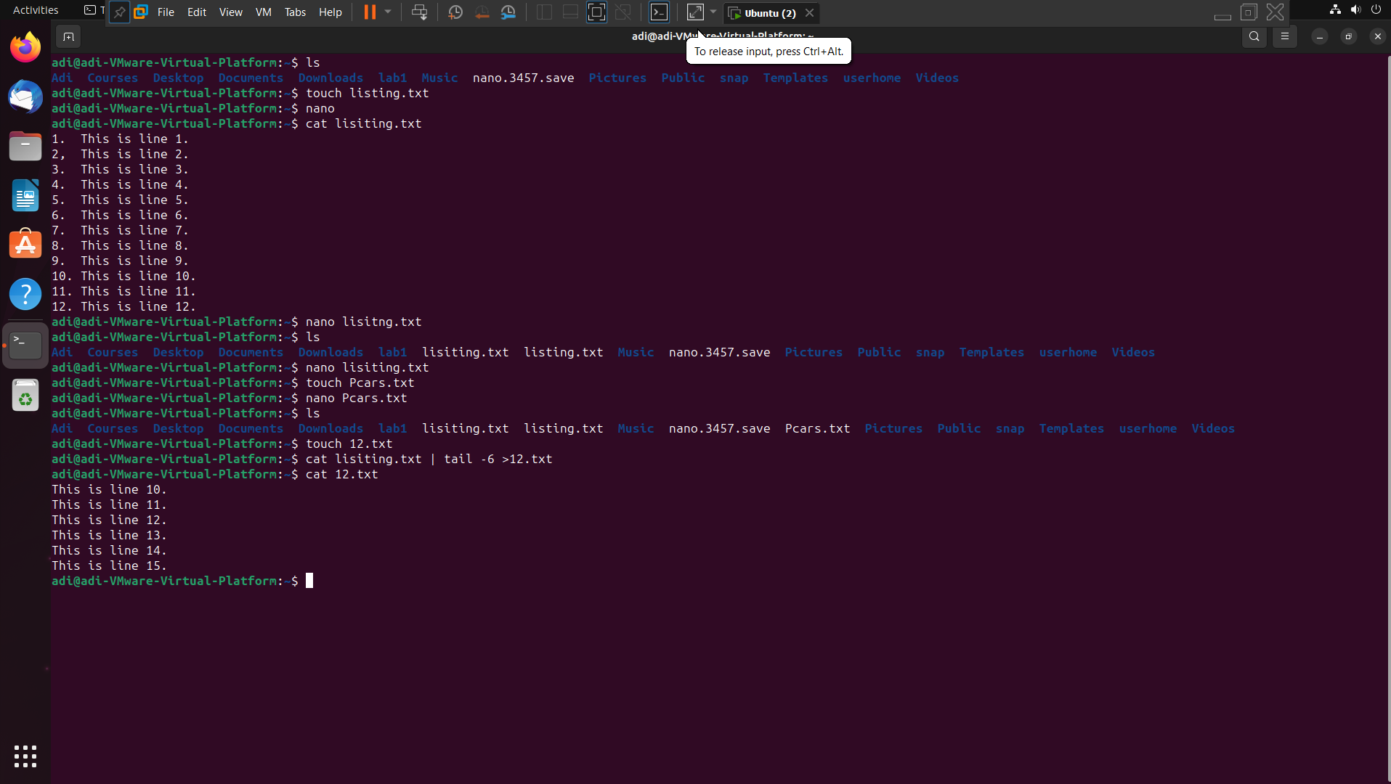

Created the files lisiting.txt & 12.txt. in the lisiting.txt we have ‘This is line 1… upto 15’.

Then what we did was we view the lisiting file with the cat command, tail it with -6 and copy the 6 to 12

Lines in the 12.txt.



Cat lisiting.txt | tail -8

In this I am viewing the the lisiting.txt file and only the from 8 to 15 lines are visible as shown above.

Cat Pcars.txt | sort



In this I am viewing the Pcars.txt and then on the same side I want it to sorted.

Cat Pcars.txt | sort > pcars2.txt

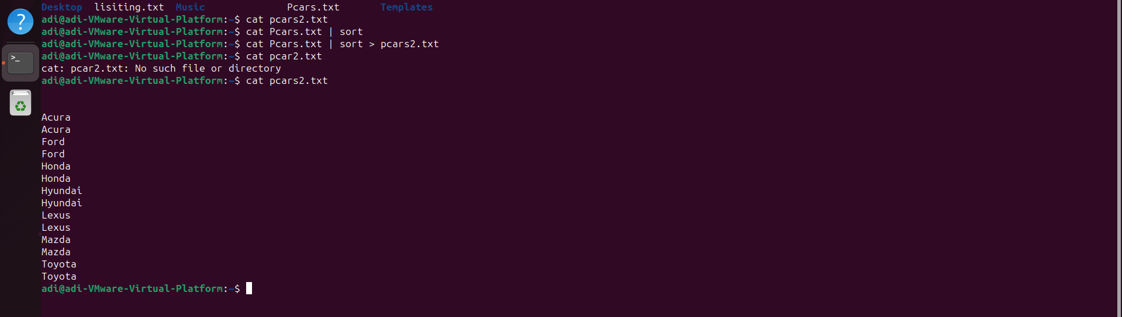

In this I am viewing the file as well as sorting the & copy the same content in the pcars.txt.



Cat lisiting.txt | wc

In this I am able to see the number of characters present in my file which is in particular



Cat lisiting.txt | wc > listingscount.txt

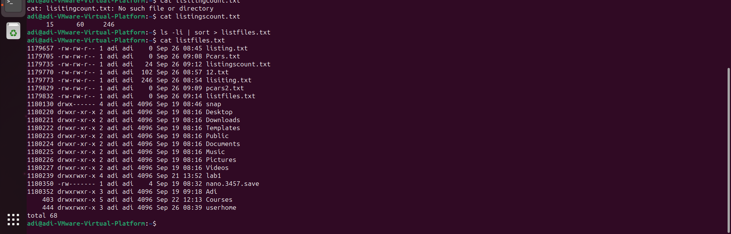

Ls -li | sort > listfiles.txt

It is showing me the directories which are present in my ubuntu also the files which consists .txt, .pptx, many more are also displayed.